- INTRODUCTION
The purpose of this document is to outline the deployment information related to the implementation of Robotics Process Automation (RPA) using UiPath for the process of Ookla Automation.
  - REFERENCES OF THE DOCUMENT
<Lists the name of the file and the locations of the process definition document and the functional requirements (PDD). In addition, it lists the references of any other documentation that has influenced the design.>
  - PROCESS DESCRIPTION
The Ookla RPA automates the extraction of the latest data. This automation runs unintendedly without human intervention.
The
  - SCOPE
<Describe the scope of automation process. Division by phases, areas involved in each phase (IT, Business), etc.>
- REQUIREMENTS
Ookla RPA process requires the following applications:
- Chrome web browser
- UiPath web extension for chrome
  - TECHNICAL REQUIREMENTS AND ASSUMPTIONS / IT
Preconditions on Running the Robot

Before the bot can automatically run, we have to ensure the following:

- Package is uploaded in the orchestrator
- Robot is connected and available
- Schedule set in orchestrator is correct
- UiPath web extensions is installed

  - REQUIREMENTS AND BUSINESS ASSUMPTIONS
<It details the business requirements and assumptions (eg, the incoming template has a fixed format, etc.). Indicate where to obtain (web site & contacts of people) with the required resources.>
- DIAGRAMS AND DESCRIPTION
  - PROCESS / BOT
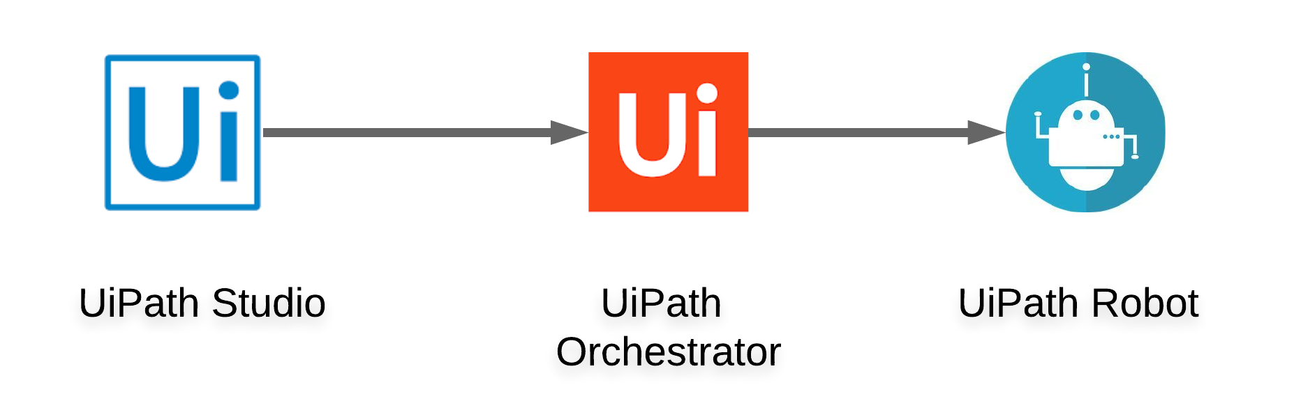
  - ACTIVITIES
<Here it must show all UiPath activities and also any COM objects and external web services, as well as the functionalities used.>
- GENERATION AND TREATMENT OF ALERTS AND EXCEPTIONS
Alerts will impact the process and business drivers. In this section if they number all the alerts and their method of communication. The definition of how to act in the face of all the alerts described should be in the ODH.
The process-lifting team must take the details and document the necessary procedures to react on those alerts in the PDD.
<Describe here the alerts that the solution of the process will send. (eg Start alerts, partial / total end alerts, exception and error alerts.>
EVENT  (Alert or Exception) | SYSTEM OR BUSINESS | ROBOT ACTION AND DETAILS
<Alert or Exception> | <System or Business> | <Communicate: Email, File, alert and detail>  <Save file and jump to next case>  <etc.>

- DATA AND CREDENTIALS SECURITY
  - DATA STORAGE
This section is to detail all data storage locations (e.g. email, network folders, etc.) that touch the operation or belong to the operation.
The operation may be necessary to develop "managements" in these data storage locations according to the records management policies.
    - DATABASE
<Details the information of the database, connections, tables, etc.>
    - EMAIL
<Insert here details e-mail folders, e-mail addresses, mail groups, mailboxes, etc.>
    - NETWORK UNITS / FOLDERS
<Insert here details of the network drives or folders.>
    - OTHERS
<Insert here details of other data support media.>
  - DATA PRIVACY
<Describe how the data will be kept private in the solution.>
  - CREDENTIALS
<Describe the Windows domains and the application credentials that will be used and if and how the robot will keep them. For applications without SSO, it is necessary to define the credential change methodology based on the methodology that is defined in document Security and audit governance.>
- ASSISTED AUTOMATION PROTOCOL
<The automated process must be adapted to local policies. It can have an assisted automation pattern that requires input / output triggers to complete / receive through the operation in addition to any mechanism for generating exception / reference reports. That pattern must be defined in this section.>
METHOD | LOCATION | FORMAT | PROGRAMMING

- MANAGEMENT INFORMATION REPORTS (MI)
<Automation may have included the generation of customized MI reports. Details the expected communication method here.>
Communication Method
<P. eg: email, Microsoft Excel spreadsheet, etc.>
Format
<Document the table format, email, file format, etc.>
Programming
<Document the receipt / exit deadline of any MI report generation.>
- AUTOMATED MASTER PROJECT DETAILS
Details filled in by the developer reflect the actual information for the master project released for production.
 | PROJECT DETAILS | DESCRIPTION
1 | Master Project Name and Version
2 | Robot Type (Specify if the process was automated for FOR or BOR or mix)
3 | Is Orchestrator used? (Yes/No)
4 | Scalable? (Yes/No)(Can the process be run by multiple robots in parallel)

- PROJECT DETAILS
<In this section describe all the projects that compose the automated process.
For each project, describe the workflow(s) in the logical order that they are called in.
If the workflow is a flowchart, also include the exported image from Studio.

If the automated process is composed of multiple projects, copy paste and fill in the table below for each project with its specific details (Sections 9.1; Section 9.2, etc.)>
  - PROJECT NAME: <PROJECT NAME>
<Add to the title of this section the actual project name of the automated process.>
    - WORKFLOW(S) SPECIFIC TO <APPLICATION NAME>
<Add to the title of this section the actual project name to which the workflows are specific to. The name should normally coincide with the Project name mentioned at Section 3.1.
Define below all the workflow files (.xaml files) used in the project, with the Input and Output data.>
 | .xaml File | Description | Input | Output
1
2
3
4

<Add more rows to the table to include all the workflow file names. No fields should be left empty. Use “n/a” for the items that don't apply to your project.
If the workflow is a flowchart, also include below the exported image from Studio.
Start the list with the one that will run by default when the package is executed.>
    - WORKFLOW(S) SPECIFIC TO <APPLICATION NAME>
 | .xaml File | Description | Input | Output
1
2
3
4

- OTHER DETAILS
  - FUTURE IMPROVEMENTS
<Include here list of all future improvements to be done on the automated project.>
  - DEBUGGING TIPS
<Include here list of debugging tips, include screenshot if possible.>

  - OTHER REMARKS
<Include here all other details that will be helpful for developers that need to understand the solution (be it for just walkthrough or for bug fixing or applying enhancements.>
- POST UAT SPECIFICATIONS
Average duration per transaction: (varies depending on the Test environment)
Recommended number of robots for the specified volumes:
Specified schedule:

- DEFINITIONS
  - DEFINITION OF TERMS
<Definition of important terminologies>
TERMINOLOGY | DEFINITION

  - ACRONYMS
<Acronyms of important terminologies>
ACRONYM | DEFINITION

